

A survey to ascertain a presence or absence for the Bog bush cricket (*Metrioptera brachyptera)* across the carbon landscape mosslands

Andrew Hankinson

Lancashire Wildlife Trust,

Wigan Office,

Worsley Mesnes Drive,

WN3 5UF

ahankinson@lancswt.org.uk

Word Count 3394



Contents

**Introduction** 3

**The Carbon Landscape** 3

**The Bog bush cricket** 3

**Project Specification** 4

**Schedule** 5

**Contingencies** 6

**Secondary research** 7

**Methodology** 8

**Results** 10

**Analysis of Pestfurlong Moss results** 10

**Analysis of Holcroft Moss results** 12

**Analysis of Little Woolden Moss results** 13

**Analysis of Cadishead Moss results** 15

**Summary table of combined results** 17

**Frequency results table** 18

**Summary table of frequency results** 22

**Evaluation** 23

**Recommendations** 24

**Acknowledgements** 25

**Bibliography** 26

# **Introduction**

## **The Carbon Landscape**

The Carbon Landscape covers an area between Salford, Wigan and Warrington and is the first project of the Greater Manchester Wetlands Partnership. A 3.2-million-pound project that is funded by the Heritage Lottery fund.

There are twenty-two different projects throughout the Carbon Landscape, ranging from habitat restoration works to empowering community groups. These projects are delivered by the Carbon Landscape Project Team and the thirteen project partners.

## **The Bog bush cricket**

Britain has a comparatively low diversity in its orthopteran species with just 30 native species, compared with over 600 species in Europe and approximately 18,000 species worldwide. Of those 30 native species there are 10 bush crickets.

This survey concentrated on the Bog bush cricket (*Metrioptera brachyptera)* and its presence within the carbon landscape. It is the only bush cricket species that is likely to occur within the mossland sites within the carbon landscape, the other species of bush cricket prefer different habitats such as dune systems or meadows.

Having contacted Greater Manchester ecology unit, Liverpool museum, Manchester museum and the LRC it became clear that records of the species are regional sparse and therefore an under recorded species across the north west and thusly is deemed to be a rarity in this region.

The Bog bush-cricket is Palaearctic and a relatively large insect, generally being about 18mm in length, females are slightly larger than males, but they can range between 10-21mm long (+ 10mm ovipositor). It is bright green underneath, brown along its sides and either brown or green along its back. The pronotum has a cream border which is restricted to the hind edge. It occurs in wet heathlands or stands of purple moor grass (*Molinia caerulea*) (Marshall and Haes 1988; Poniatowski, D & Fartmann T.J, 2010).) However, the species can also be found in semi-dry calcareous grasslands (Poniatowski, D & Fartmann T.J, 2010). Although other sources suggest that it prefers any habitat exposed to sun showing a preference to outcrops, swamps and cleared wooded areas and omits arable land and pasture (F. Holmer, 2017). Nymphs hatch in May and progress through six instar phases before becoming adults (Marshall & Haes, 1988). Bush-crickets can be distinguished from grasshoppers as they have very long antennae - much longer than the length of their body.

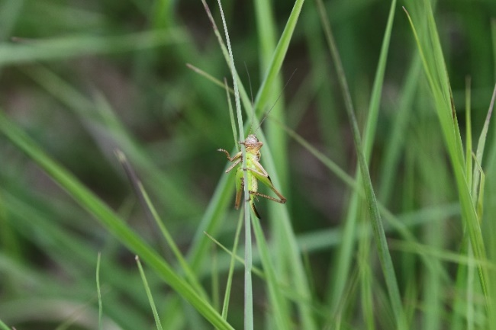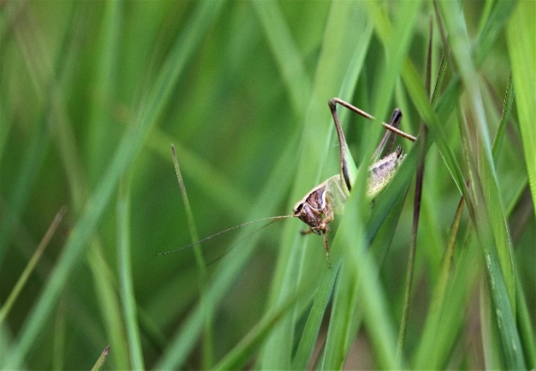

Figure 1 - BBC male, note cream hind edge on pronotum

Credit – Andrew Hankinson

Figure 2 - BBC female, note distinct green underside

Credit – Andrew Hankinson

# **Project Specification**

The aims of the project were twofold. Firstly, to ascertain whether the Bog bush cricket (*Metrioptera brachyptera*) occurs on a number of sites that fall within the carbon landscape. Hopefully gaining a base line figure which can be used to track species presence moving forward whilst restoration work is undertaken.

Secondly the surveys that are undertaken should provide information on the practicality of using bat detectors to assist in surveying for the Bog bush cricket (*Metrioptera brachyptera*) in the field. Specifically, the range that they are useful and frequency that the stridulating of the male Bog bush cricket (*Metrioptera brachyptera*) is most audible.

Having conducted site visits to all seven of the mossland sites; Highfield, Astley, Little Woolden, Cadishead, Holcroft, Pestfurlong and Risley, see *fig 3*. It is clear that all sites have some potential for accommodating the Bog bush cricket (*Metrioptera brachyptera*). In that they all hold the relevant floral species. What I expect to gain is a base line for each site, so the minimum expectation is that all sites will have a presence or no presence record.

The survey may also provide a deeper understanding of the specific types of flora the Bog bush cricket (*Metrioptera brachyptera*) favours i.e. Purple moor grass (*Molinia caerlunae*), Heather (*Calluna vulgaris*) and Cross leaved heath (*Erica tetralix*). (SWSEIC, n.d; Buglife, n.d)

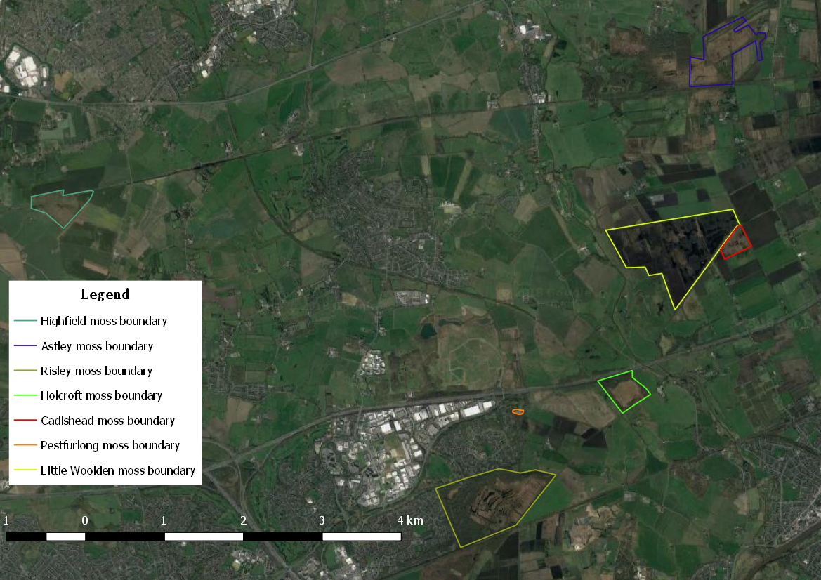

Figure 3 - Mossland sites

# **Schedule**

|  |  |  |  |  |
| --- | --- | --- | --- | --- |
| **Activity** | **Required actions** | **When** | **No. of hours** | **Completed date** |
| Email site managers for permission to access site | Email | ASAP | 0.5 | 31.05.2018 |
| Talk to Peter Brighton about survey method | Phone call | ASAP | 0.5 | 31.05.2018 |
| Research the Bog bush cricket, collate info | Research via regional experts, internet and books | On going | 5 | 28.06.2018 |
| Contact Steve Atkins for survey form template | Email | ASAP | Nil | 31.05.2018 |
| Contact Manchester & Liverpool museum in regards to prior records | Email | ASAP | 0.5 | 31.05.2018 |
| Apply for grant from Tanyptera project | Email Gary Hedges with application form | ASAP | 1 | 14.06.2018 |
| Upon acceptance of grant (if applicable) Order FSC guides on Orthoptera species and 2 bat detectors | Order direct from FSC and bat detectors from amazon | After acceptance of grant application | 0.5 | 18.06.2018 |
| Conduct site visits for all 7 sites | Physically visit the sites and walk potential transects | Before the end of June | 21 | 21.06.2018 |
| Book a venue for the training session | Book Irlam fire station online | ASAP | 0.5 | 07.06.2018 |
| Create marketing poster and advertise on facebook and website | Source BBC picture, confirm time and dates. Create in publisher | Once venue is confirmed | 0.5 | 14.06.2018 |
| Write up risk assessment for the survey |  | Before end of June | 0.5 | 05.06.2018 |
| Gather risk assessments for the 7 sites | Email relevant site officers | Before end of June | 0.5 | 28.06.2018 |
| Draw up transects | Using GMEU’s map app | Before end of June | 3.5 | 21.06.2018 |
| Write up methodology | Write up in word | Before end of June | 2 | 01.06.2018 |
| Run training session | Lead training session | 02.07.2018 | 7 | 02.07.2018 |
| Await results, once results in collate the data and write up findings | Results can be emailed or posted to me | By the end of September ideally | 8 |  |

*Table 1 – Schedule*

## **Contingencies**

Possible issues that may arise from the schedule are the following:

* The grant application being rejected so no further bat detectors can be purchased.
* Nobody attends the training session or not enough people attend to cover all 7 sites.
* Not all results are sent back once the surveys have been completed.

If the grant application is rejected, then bat detectors could be borrowed from the Bolton office of the Lancashire wildlife trust. Volunteers who sign up to the training could also be asked if they have their own to use.

If nobody attends the training, then I will complete the surveys myself with the help of fellow carbon landscape trainees and long term volunteers.

Volunteers who sign up to survey a site will be given my contact details to send me the results via email or via post. A record of who is surveying each site will be kept on record which will also contain their contact details, name, email, address and phone number.

# **Secondary research**

Having contacted Manchester museum, Liverpool museum, the Record LRC, Tanyptera trust and Greater Manchester Ecology unit (GMEU) it is clear that the recording of the Bog bush cricket in the North west is somewhat lacking.

Manchester & Liverpool museum had no records or specimens, Record LRC only had records for Holcroft moss dating back to 2010. GMEU had 3 records from Little Woolden moss but no details on dates and the Tanyptera trust had no records for any of the sites within the carbon landscape.

Based on this I envisage that a presence will be detected on Holcroft and Little Woolden moss. Because of the fragmented state of the landscape (Fig. 3) and flightless, sedentary nature of the Bog bush cricket (*Metrioptera brachyptera*) (Poniatowski, D & Fartmann T.J, 2010) it is unlikely that they will have naturally migrated to other sites. Because of this it is unknown if there will be a presence on the other sites even though they all have suitable habitat in that they contain Purple moor grass (*Molinia caerlunae*), Heather (*Calluna vulgaris*) and Cross leaved heath (*Erica tetralix*). (SWSEIC, n.d; Buglife, n.d).

Although they all contain the relevant floral species they occur in varying abundance and although the sites are all of the same habitat, lowland raised peat bog, they do also vary in their level of quality. Some sites have been historically cut for peat so are in a degraded state undergoing restoration. Poniatowski & Fartmann, 2010 stated that the main driver of the presence of Bog bush crickets (*Metrioptera brachyptera*) is habitat quality, and this quality is mainly determined by land use (Kruess and Tscharntke 2002; Marini et al. 2009), vegetation structure (Poniatowski and Fartmann 2008) and microclimate (Willott and Hassall 1998; Gardiner and Dover 2008). The degradation of the sites will have influenced vegetation structure and the use of the land, peat cutting, will certainly have affected the habitat quality. But it has been suggested that orthopteran species can persist in fairly small (Ko¨hler 1996; Maes et al. 2006; Theuerkauf and Rouys 2006) and often isolated habitat patches (Reinhardt and Ko¨hler 2002).

Therefore, a presence is expected on all of the 7 moss land sites because the floral species required for its lifecycle all exist on every site.

# **Methodology**

The primary research methodology concentrated on surveying seven moss land sites within the carbon landscape; Highfield, Astley, Little Woolden, Cadishead, Holcroft, Pestfurlong and Risley. Pestfurlong.

Each site will be surveyed by two volunteers with the use of bat detectors, the reasoning behind limiting the number of surveyors to two is to limit habitat disturbance since two of the sites, Risley & Astley, are of SSSI status. To retain a level of consistency the same number of volunteers will survey each site. The surveys will be undertaken between July and August and where possible under favourable conditions >17 degrees (Orthoptera and Allied insects, n.a)

Given that the main aim is to ascertain a presence or absence of Bog bush crickets (*Metrioptera brachyptera*) and not determine a specific population figure a transect method will be employed. Previous surveys have used transects to survey for Orthoptera species with varying transect lengths used. For example, IsernVallverdu et al. (1993) counted the number of adult grasshoppers displaced by an observer in a band of 0.5 m width along 10 m transects, whereas, Kruess and Tscharntke (2002) counted Orthoptera displaced along 30-min transect walks and Wettstein and Schmid (1999) in 60 second walks along a 1·20 m transect.

On this basis there appears to be no preference in regards to transect length when surveying for Orthoptrea species. This solidifies the decision to employ a transect length that is suitable for each site so that the entirety, or as close as is reasonable, of the site can be covered. So the total transect length will vary from site to site but all transects will be broken down into 60m intervals. An interval length of 60 metres totalling 600 metres will be employed, if necessary to cover the entire site a further 600m transect will be employed ad infinatum. If it is not possible to have the transect end at either 600, 1200, 1800 metres etc then individual 60 metre intervals will be added until the majority of the site has been surveyed. The reasoning behind this is that the range of a bat detector should be up to between 25-30 metres (Wikipedia, n.a) (M. Lee, 2004). To detect a Bog bush cricket (*Metrioptera brachyptera*) it could be as low as 15 metres (Lee, 2004), but to work at 15 metre intervals would extend the length of the surveys by twice as long. Given the time of year, the health and safety of surveyors must be considered. Being out on open and exposed mossland in summer heat is not advisable for extended periods of time.

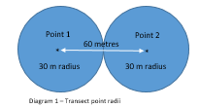Referring to *Diagram 1* surveyors will stand at point 1, use the bat detector then walk 60 metres from that initial point; this should allow the maximum radii to link therefore covering the highest possible area in the shortest transect length.

Diagram 1 – Radii points of bat detector range

There will be no need to use a displacement method as bat detectors will be used, the detectors should have an average range at mid-range frequencies of around 25 to 30 metres. This should give enough scope to cover the majority of the sites planned for surveying.

Once the bat detector picks up a reading (expected frequency 20-40 kHz) the surveyor will try to narrow down where the Bog bush crickets (*Metrioptera brachyptera*) may be using the bat detector’s increase in output to lock onto the specific location and then begin to scan the vegetation for the individual. If no individual can be seen the surveyor will simple record that the species is present. If an individual can be seen and identified, then the surveyor will record an X and whether it was a male or female, then record a grid reference on the survey form. If more than one individual is sighted within the same 60m interval, then the surveyor will record the specific number as opposed to an X i.e. 1,2 or 3.

Since a transect requires the surveyor to observe and identify the species without capture this method should keep disturbance of the habitat to a minimum. To aid in this, training was provided to surveyors which covered how to correctly identify the Bog bush crickets (*Metrioptera brachyptera*) and surveyors were advised to use long lens cameras and/or binoculars.

Transect methods suﬀer from problems associated with immigration, emigration, re-counting and spatial heterogeneity of vegetation. The potential problems associated with the aforementioned has been examined by Buckland & Turnock.(1992) and Gardiner & Hill (2006) and due to the nature of Bog bush crickets (*Metrioptera brachyptera*) not moving great distances (Kindvall and Ahle´n 1992; Hein et al. 2003; Dieko¨tter et al. 2005, 2007) emigration should not be an issue. This should not negatively impact the surveys as previously stated the aim is to ascertain existence of the species on site.

# **Results**

Of the seven sites surveyed four returned a presence and three returned a no presence result. The results are broken down into the individual sites which returned a presence and include both auditory and visual records. Further information on weather conditions, times in which the surveys were completed and subjective information on the frequencies when the stridulating was at its most audible have all been included.

## **Analysis of Pestfurlong Moss results**

The results from the survey show a presence across the entire site. Individuals which were directly sighted were seen to be on Purple moor grass (*Molinia caerlunae)* as opposed to Heather *(Calluna vulgaris).*

Frequencies were recorded when a presence was detected, the average frequency from the survey on the 10.07.2018 was 34 kHz and 29 kHz from the 30.08.2018. Giving an overall average frequency of 31.5 kHz.

Over the two surveys there was a marked difference in the temperature recorded at 25 degrees and 15 degrees respectively and the times the surveys were performed had start times of 15:20 and 11:10 and end times of 16:00 and 12:00. Cloud cover on survey 1 was recorded at 0% and survey 2 at 100% wind speed was recorded at of 0 on the beaufort scale for both surveys.

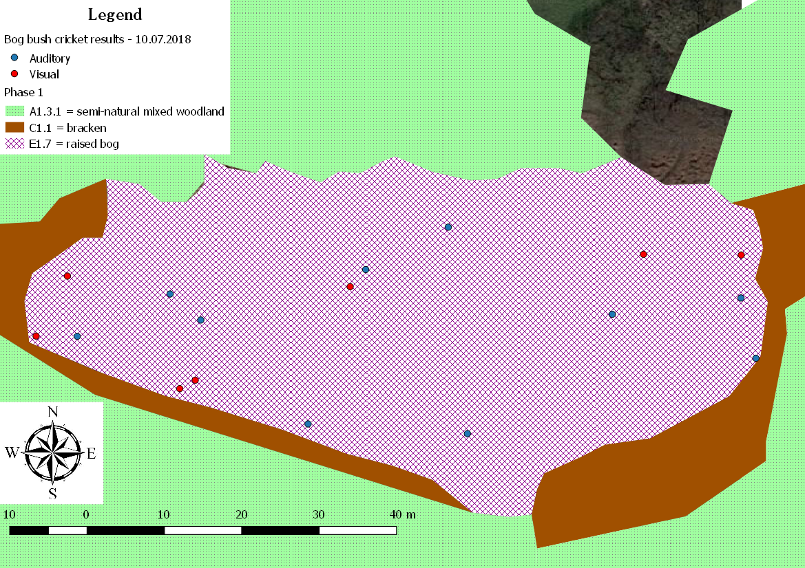

Figure 3 - Results from 10.07.2018

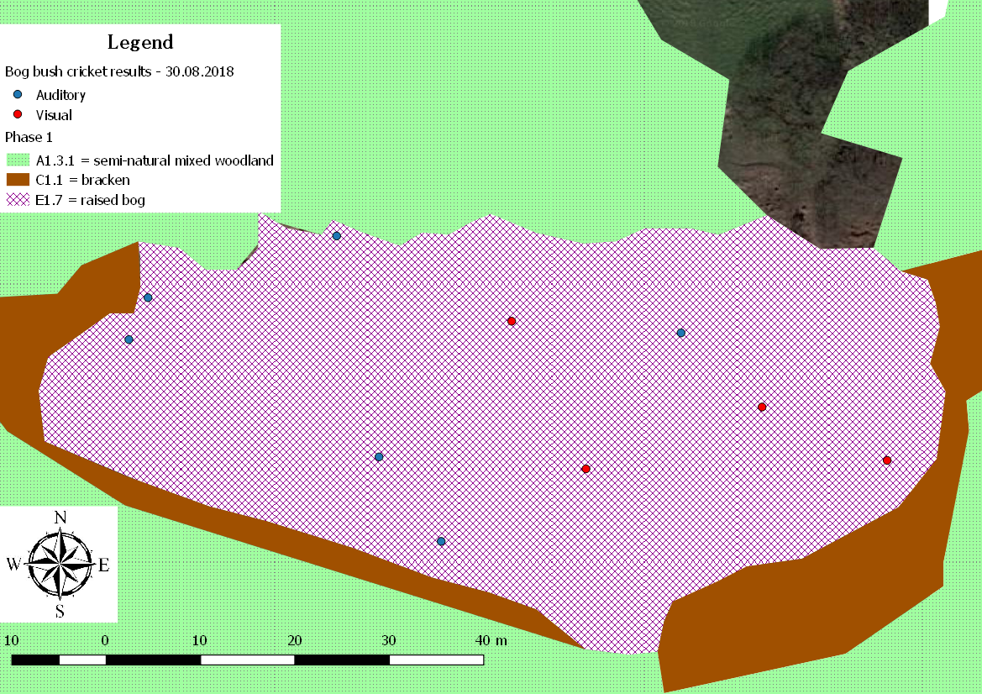

Figure 4 - Results from 30.08.2018

## **Analysis of Holcroft Moss results**

The results from the survey show a presence across the entire site. There were clearly more individuals detected around the edge of the site where they appeared to be constant when compared to the central areas of the site. Individuals which were directly sighted were seen to be on Purple moor grass (*Molinia caerlunae*) as opposed to Heather *(Calluna vulgaris)*

Two surveys were completed at Holcroft moss but neither had any sufficient details on frequency, grid references and end times and there were missing details on air temperature. Based on this a further survey was completed on 30.08.2018. Although information was missing from the previous two surveys on 31.07.2018 & 29.08.2018 presence records were recorded so have been included in table 1.

Frequencies were recorded when a presence was detected, the average frequency from the survey on the 30.08.2018 was 29 kHz giving an overall average frequency of 29 kHz.

Based on the details available temperature on the 31.07.2018 was recorded at 21 degrees and on the 30.08.2018 at 17 degrees. Start times of the surveys varied with the 31.07.2018 starting at 10:30 and the survey on the 30.08.2018 at 14:20. Based on total time of the survey completed on the 30.08.2018 it would be far to assume an end time for the 31.07.2018 being around 12:30. Cloud cover on the 31.07.2018 was recorded initially at 25% rising to 85% as the survey went on and wind speed at 3. On the 30.08.2017 cloud cover was recorded at 40% and wind speed at 0.

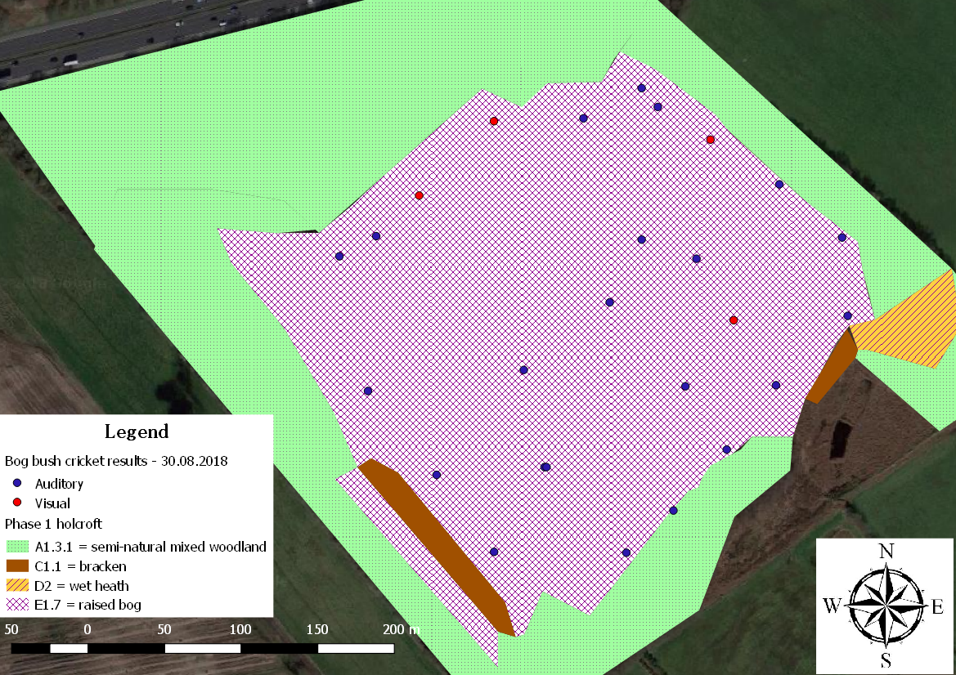

Figure 5 - Results from 30.08.2018

## **Analysis of Little Woolden Moss results**

The results from the survey show a presence across the entire site. Individuals which were directly sighted were seen to be on Purple moor grass *(Molinia caerlunae*) as opposed to Heather *(Calluna vulgaris)*.

Frequencies were recorded when a presence was detected, the average frequency from the survey on the 4.07.2018 was 31 kHz and 29 kHz from the 30.08.2018. Giving an overall average frequency of 30 kHz.

Over the two surveys there was a marked difference in the temperature recorded at XX degrees and 15 degrees respectively and the times the surveys were performed were near identical with start times of 14:00 and 11:10 and end times of 16:00 and 12:00. Cloud cover on survey one was recorded at 20% and survey 2 at 100% wind speed varied at a recording of 1 and 0 on the beaufort scale.

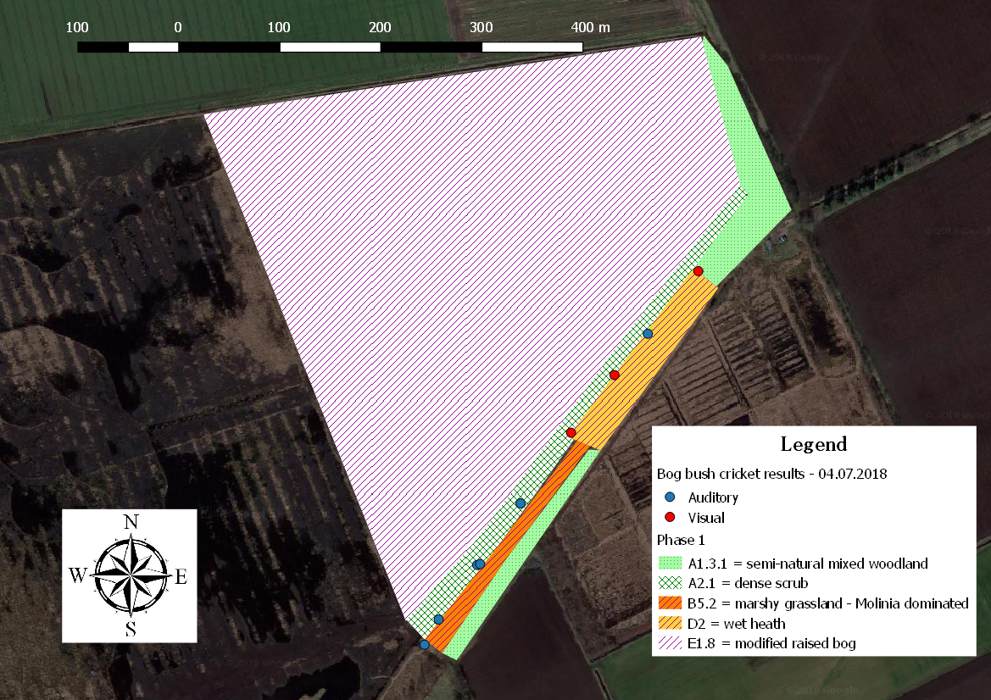

Figure 6 - Results from 15.07.2018

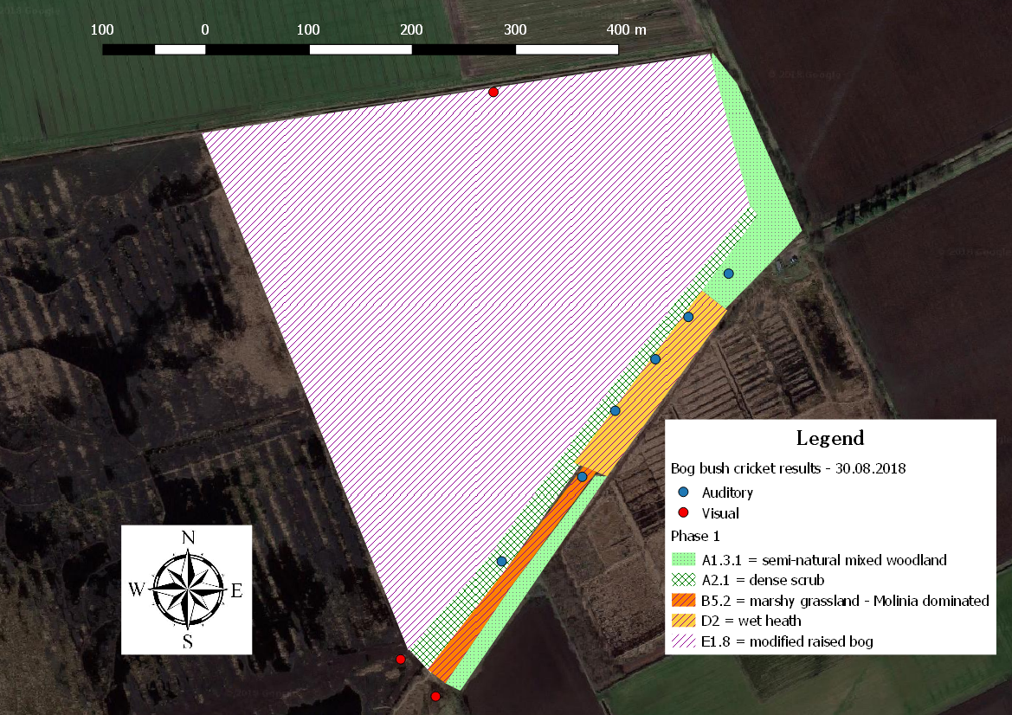

Figure 7 - Results from 30.08.2018

## **Analysis of Cadishead Moss results**

The results from the survey show a presence across the entire site apart from a small section to the north east. This may be because this particular section is much wetter than other areas of the site. Only one individual was directly sighted and this was perched within the Purple moor grass (*Molinia caerlunae*).

Frequencies were recorded when a presence was detected, the average frequency from the survey on the 18.07.2018 was 29 kHz and 32 kHz from the 15.08.2018. Giving an overall average frequency of 30.5 kHz.

Over the two surveys there was negligible difference in the temperature recorded at 21 degrees and 22 degrees respectively and the times the surveys were performed were near identical with start times of 12:38 and 12:25 and end times of 14:55 and 15:00. Cloud cover on both surveys was recorded at 100% and wind speed varied at a recording of 1 and 4.

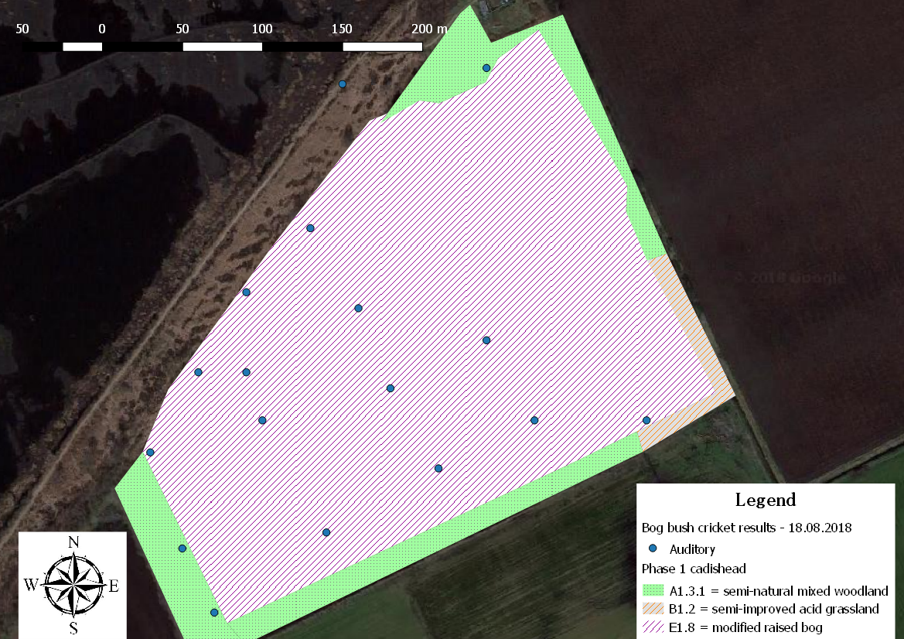

Figure 8 - Results 15.07.2018

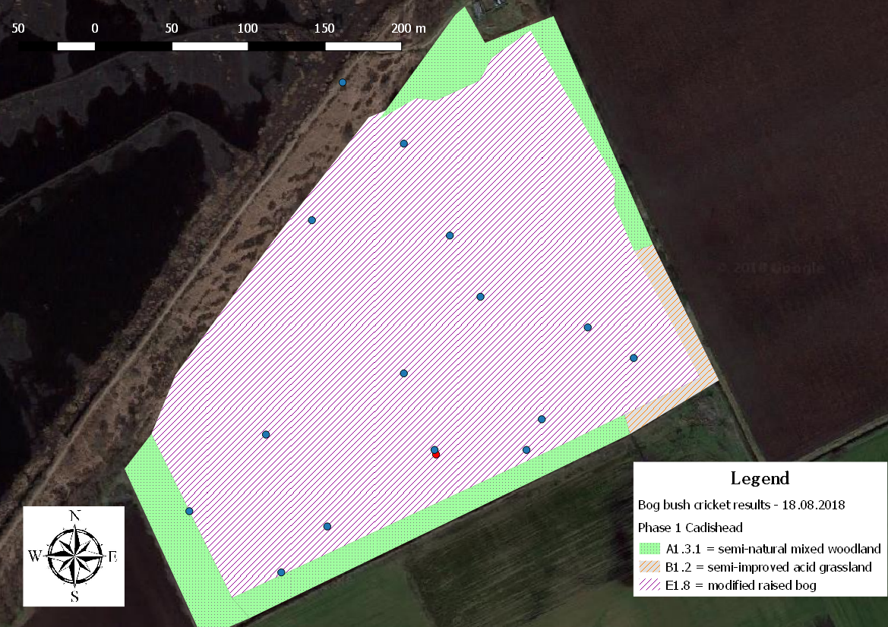

Figure 9 - Results from 18.08.2018

# **Summary table of combined results**

|  |  |  |  |  |  |
| --- | --- | --- | --- | --- | --- |
| **Transect Location** | **Bat detector** | **Visual**  **Male (m) / Female (f)** | **Total** | **Transect length** | **\*Estimated BBC’s per 100m** |
| Astley Moss | 0 | 0 | 0 | 0 | 0 |
| Cadishead Moss | 33 | 1 f | 34 | 1190 | 2.857 |
| Highfield Moss | 0 | 0 | 0 | 0 | 0 |
| Holcroft Moss | 26 | 21 m 3 f | 50 | 1513 | 3.304 |
| Little Woolden Moss | 12 | 6 m | 18 | 1753 | 1.026 |
| Pestfurlong Moss | 16 | 10 m 1 f | 27 | 201 | 13.432 |
| Risley Moss | 0 | 0 | 0 | 720 | 0 |

*Estimate calculated by dividing the sum total of bat detector and visual sightings by the length of transect walked (in m) x 100 (Gardiner *et al* 2010)

Of the forty-two individuals directly sighted all were seen to be on Purple moor grass (*Molinia caerlunae*) as opposed to Heather (*Calluna vulgaris*). Although Heather does exist on all four sites Purple moor grass (*Molinia caerlunae*) occurs in a greater abundance, Cross leaved-heath *(Erica tetralix)* occurs sporadically on both Little Woolden and Holcroft.

# **Frequency results table**

Graph 2 - Pestfurlong frequency recordings

Graph 4 - Little Woolden moss frequency recordings

Graph 5 - Holcroft frequency recordings

# **Summary table of frequency results**

|  |  |  |  |  |  |  |  |  |
| --- | --- | --- | --- | --- | --- | --- | --- | --- |
| **Transect Location** | **Pestfurlong Moss** | | **Little Woolden Moss** | | **Holcroft Moss** | | **Cadishead Moss** | |
| Average frequency (kHz) per survey | 10.07.2018 | **34** | 04.07.2018 | **31** | DD | **DD** | 18.07.2018 | **29** |
| 30.08.2018 | **29** | 30.08.2018 | **29** | 30.08.2018 | **28** | 15.08.2018 | **32** |
| Average frequency (kHz) | **31.5** | | **30** | | **28** | | **30.5** | |
|  |  | |  | |  | |  | |
| Total Average frequency (kHz) | **30** | | | | | | | |

# **Evaluation**

Considering the minimum expectation of this survey was to ascertain a presence or absence record for the seven mossland sites within the carbon landscape this expectation has been met with results showing a presence on four sites and an absence on three of the sites.

The secondary aim of finding out how useful bat detectors were in the field specifically their range and frequency for detecting Bog bush crickets (*Metrioptera brachyptera*) was achieved. As stated in the methodology the range was expected to be 25-30 metres and it was this information that drove the transect length. In reality a range of 30 metres was not achieved it was more than likely half that of that or less. But despite this the use of bat detectors in surveying for the Bog bush crickets (*Metrioptera brachyptera*) proved to be of great help and assisted in gaining a presence or absence recording.

Frequency averaged out at 30 kHz across the four sites although detection was still audible between 25 – 40 kHz in general but in some instances was still audible at 125 kHz. This is more than likely down to proximity but anthropogenic interference and weather conditions could also have influenced this. Overall the secondary aim of this survey has been achieved in that there is further data and understanding of the specific frequency the stridulating male is audible, 30 kHz appearing to be optimal. Further information around the range in which bat detectors pick up the stridulating is necessary but it appears fair to say that a 30 metre range is ambitious at best based on verbatim from surveyors.

A further potential outcome of the survey was an insight into the Bog bush crickets (*Metrioptera brachyptera*) reliance on Purple moor grass (*Molinia caerlunae*), Heather (*Calluna vulgaris*) and Cross leaved heath (*Erica tetralix*). It would appear from the results that the Bog bush crickets (*Metrioptera brachyptera*) have little to no reliance on Cross leaved heath (*Erica tetralix*) in this region. The information where this was sourced as a floral species required for its lifecycle came from Scotland which may indicate a regional variance in preference or a simple case of using what is available. Having sighted all individuals on Purple moor grass (*Molinia caerlunae*) it can be determined that this species is of particular importance, not wholly unsurprising as this is where the female will oviposit her eggs, but it is also interesting that there appears to be a preference to being within an area with suitable breeding or laying conditions as opposed to a food source. Which raises the question how often do they eat given their general disposition to not move very far.

The fact that three of the sites returned an absence record comes as somewhat of a surprise especially considering two of those sites are designated SSSI’s and have the required floral species for the Bog bush crickets (*Metrioptera brachyptera*) lifecycle. Having looked further into history of the SSSI sites there was periodic burning of these sites which could explain the absence of Bog bush crickets (*Metrioptera brachyptera*). As this burning would have killed any individuals and any eggs that had been laid on Purple moor grass (*Molinia caerlunae).*

# **Recommendations**

Further surveys into how often the Bog bush crickets (*Metrioptera brachyptera*) feed or how far away they are found from their food source would provide some interesting information as would further surveys to determine how long they spend on Heather (*Calluna vulgaris*) and what specifically they feed on. The flowers, leaves, other smaller insects using the Heather (*Calluna vulgaris*)?

Feasibility studies into the sites where an absence was recorded could be undertaken to determine whether the Bog bush crickets (*Metrioptera brachyptera*) could be introduced to the sites. It could be that they were once there but since records are so sparse for the region prior to these surveys it would be near impossible to know so it perhaps would need to be classed as an introduction. In order to do this further information on whether the Bog bush crickets (*Metrioptera brachyptera*) have any negative impact on any other species would be needed to prevent disruption to the local flora and fauna.

Another, more robust survey, could be performed to test the range of bat detectors picking up the stridulating male. This could be done by having surveyors pacing out the distance between when an output occurs and when the stridulating stops. As the surveyor gets closer to the individual Bog bush cricket (*Metrioptera brachyptera*) the output should increase in volume until the stridulating stops because the surveyor is in such close proximity to the individual. Therefore, an estimate could be achieved through counting the paces from the start of the detection to when the stridulating stops.

# **Acknowledgements**

Mike Longden (Lancashire wildlife trust)

Steve Atkins (GMEU)

Phillip Brighton (Volunteer ranger at Holcroft moss)

Gary Hedges (Tanyptera Regional Entomology Project Officer, Liverpool Museum)

Dr. Dmitri V. Logunov (Curator of Arthropods, The Manchester Museum)

Eric Fletcher (RECORD LRC)

Mark Cozens (Ranger, Risley Moss)

Sarah Bennet (Area manager for Cheshire wildlife trust)

Martyn Walker (Lancashire wildlife trust)

Friends of Chat moss

Anthony Da Silva (Lancashire wildlife trust)

And of course all the volunteers involved in undertaking a survey site; Steve Ormerod, Andy Osbourne, Jamie Lawson, Paulina Drozdowskap, Marie Mcol, Ken Gartside, Melanie Murray, Phillip Whiteman and Sonia Allen

# **Bibliography**

Marshall JA, Haes ECM (1988) Grasshoppers and allied insects of Great Britain and Ireland. Harley, Colchester

D. Poniatowski & T.J Fartmann. (2010). What determines the distribution of a flightless bush-cricket (Metrioptera brachyptera) in a fragmented landscape. Journal of Insect Conservation. Vol 14. Issue 6. Pages 637-645.

F. Holmér. (2017). The effect of agricultural land-use on bushcricket and grasshopper diversity. Available [Online] <https://stud.epsilon.slu.se/10239/1/holmer_f_170608.pdf>. [Accessed on 26.07.2018].

Andrew Hankinson, 2018. BBC Male. Private collection.

Andrew Hankinson, 2018. BBC Female. Private collection.

South West Scotland Environmental information centre (SWSEIC**)**. (n.d). Bog Bush-cricket. Available [Online] <https://swseic.org.uk/what-to-see/dumfries-galloway/species/crickets-and-grasshoppers/bog-bush-cricket/>. [Accessed on 26.07.2018].

Buglife. (n.d). Species profile Bog-Bush Cricket. Available [Online] <https://www.buglife.org.uk/sites/default/files/lessons/Lesson%202%20Species%20Profile%20-%20Bog%20bush%20cricket%20-%20Supporting%20Worksheet_0.pdf>. [Accessed on 26.07.2018].

Kruess A, Tscharntke T. (2002). Grazing intensity and the diversity of grasshoppers, butterflies, and trap-nesting bees and wasps. Conserv Biol. Vol 16. Pages 1570–1580.

Marini L, Fontana P, Battisti A, Gaston KJ. (2009). Response of orthopteran diversity to abandonment of semi-natural meadows. Agric Ecosyst Environ. Vol 132. Pages 232–236.

Poniatowski D, Fartmann T. (2008). The classification of insect communities: Lessons from Orthoptera assemblages of semi-dry calcareous grasslands in central Germany. Eur J Entomol. Vol 105. Pages 659–671.

Willott SJ, Hassall M. (1998). Life-history responses of British grasshoppers (Orthoptera: Acrididae) to temperature change. Funct Ecol. Vol 12. Pages 232–241.

Gardiner T, Dover J. (2008). Is microclimate important for Orthoptera in open landscapes? J Insect Conserv. Vol 12. Pages 705–709

Köhler G. (1996). The ecological background of population vulnerability in Central European grasshoppers and bush-crickets: a brief review. In: Settle J, Margules CR, Poschold P, Henle K (eds) Species survival in fragmented landscapes. Kluwer, Dordrecht, Pages 290–298.

Maes D, Ghesquiere A, Logie M, Bonte D. (2006). Habitat use and mobility of two threatened coastal dune insects: implications for conservation. J Insect Conserv. Vol 10. Pages 105–115.

Theuerkauf J, Rouys S. (2006). Do Orthoptera need human land use in Central Europe? The role of habitat patch size and linear corridors in the Bialowieza Forest, Poland. Biodiv Conserv. Vol 15. Pages 1497–1508.

Reinhardt K, Köhler G. (2002). Bedeutung aktueller Befunde der Verhaltensökologie für den Artenschutz. Dargestellt am Beispiel der Heuschrecken. Natursch Landschaftspl Vol 34. Pages 171–180.

Orthoptera and Allied insects. (n.a). Grasshoppers. Available [Online] https://www2.habitas.org.uk/records/sites/default/files/Survey_methodology_for_CEDaR_Grasshopper_survey.pdf. [Accessed on 01.07.2018].

Isern-Vallverdu, J, C. Pedrocchi-Renault, and J-F. Voisin. (1993). A comparison of methods for estimating density of grasshoppers (Insecta: Orthoptera) on Alpine pasturelands. Revue d'Ecologie Alpine II. 73–80.

W. Wettstein & B. Schmid (1999). Conservation of arthropod diversity in montane wetlands: effect of altitude, habitat quality and habitat fragmentation on butterflies and grasshoppers. Journal of applied ecology. Vol 36. Issue3. Pages 363 – 373.

Kruess A & Tscharntke T (2002). Grazing intensity and the diversity of grasshoppers, butterflies, and trap-nesting bees and wasps. Conserv Biol Vol 16. Pages 1570–1580.

Wikipedia. (n.a). Bat detector. Available [Online] <https://en.wikipedia.org/wiki/Bat_detector>. [Accessed on 01.07.2018].

M. Lee. (2004). Bat Detectors – A Beginner’s Guide for Orthopterists. Avialbale [Online] <http://erccis.org.uk/sites/default/files/docs/Species%20Guide%20Bat%20Detectors%20for%20Orthopterists.pdf>. [Accessed on 01.07.2018].

S.T, Buckland & B.J, Turnock. (1992) A robust line transect method. Biometrics. Vol 48. Pages 901-909.

T. Gardiner and J. Hill. (2006). A comparison of three sampling techniques used to estimate the population density and assemblage diversity of Orthoptera. Journal of Orthoptera Research. Vol 15. Pages 45-51.

Kindvall O, Ahle ´n I (1992) Geometrical factors and metapopulation dynamics of the bush cricket, Metrioptera bicolor Philippi (Orthoptera: Tettigoniidae). Conserv Biol Vol 6. Pages 520–529.

Dieko ¨tter T, Csencsics D, Rothenbu ¨hler C, Billeter R, Edwards PJ (2005) Movement and dispersal patterns in the bush cricket Pholidoptera griseoaptera: the role of developmental stage and sex. Ecol Entomol Vol 30. Pages 419–427.

Dieko ¨tter T, Speelmans M, Dusoulier F, van Wingerden WKRE, Malfait JP, Crist TO, Edwards PJ, Dietz H (2007) Effects of landscape structure on movement patterns of the ﬂightless bush cricket Pholidoptera griseoaptera. Environ Entomol Vol 36. Pages 90–98.

Hein S, Gombert J, Hovestadt T, Poethke H-J (2003) Movement patterns of the bush cricket Platycleis albopunctata in different types of habitat: matrix is not always matrix. Ecol Entomol Vol 28. Pages 432–438.